**DIY Face Mask**

**Designer Jennifer Maker**

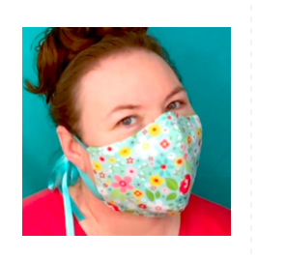

**Materials**

* Tightly woven Cotton or Cotton Blend Fabric (quarter of a yard) for the first two layers
* 1/4" - 3/8" Binding for ties (at least 72 inches)- Make your own o use prepackaged. This does not have to be on the bias!!
* Thread
* Sewing Machine
* Scissors (for cutting fabric and ribbons)
* Pins (for keeping pieces of fabric together)

**Instructions:**

**Step 1:** Cut out 2 pattern pieces for the top fabric and 2 pattern pieces for the backing. There are three different sizes to choose from - small, medium, and large. If you're cutting this face mask by hand, just print out the printable PDF, cut out each piece as directed, and use it to trace the patterns onto your fabric. Once you've traced the shapes, measure in 3/8" on all sides and mark (for seam allowance) and cut out your fabric.

* There are pattern pieces for the filter. We are not using filters at this time.

** The following has been suggested:

To go over N95 mask, size medium and large works best with two layers of quilting cotton with two pleats.

To use independently, three layers of cotton in a size medium/large with one pleat.

Tip: If you plan to make a LOT of these, print out your patterns on card stock for tracing!

**Step 2**: Sew your DIY face mask halves together

After you've finished cutting out your face mask pieces, take your fabric pieces and line up the two halves of each set, right sides together, and sew along the curved outer edge, attaching the two pieces together.

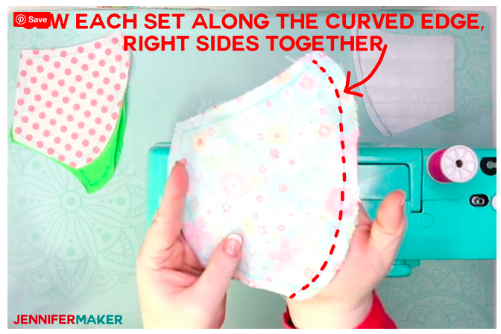

Do the same thing for the backing piece.

**Step 3:** Set your iron to the cotton setting and press your seams open and flat on all pieces.

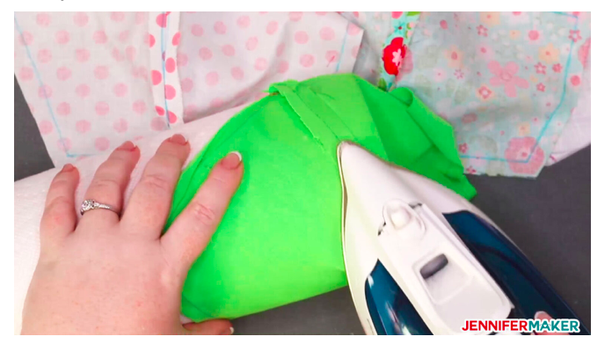

### **Step 4:** Pin and baste your ties to each corner of your DIY face mask

Cut four 18" pieces of binding.

**Step 5:** Pin one tie to each corner of your inner fabric layer about 3/8" down, like this:

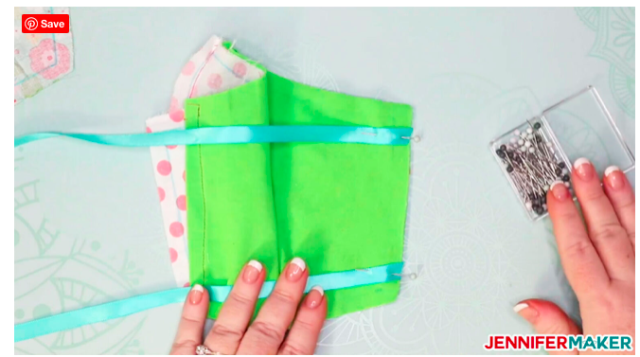

Baste each tie in place.

### **Step 6:** Sew up your DIY face mask!

Place your outer fabric layer on top of your inner fabric layer, right sides together.

Tuck your ties inside to make sure you don't "catch" them while sewing your pieces together. I just pulled one set all the way through to the other side to make sure they were free and clear.

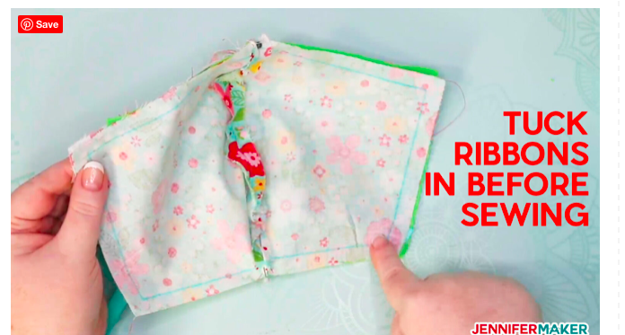

Sew around the top, edge, and bottom of the face mask layers, 3/8" from the edge, leaving one side open. Reinforce the ties by going over them and backstitching.

**Step 7:** Clip each corner to reduce bulk.

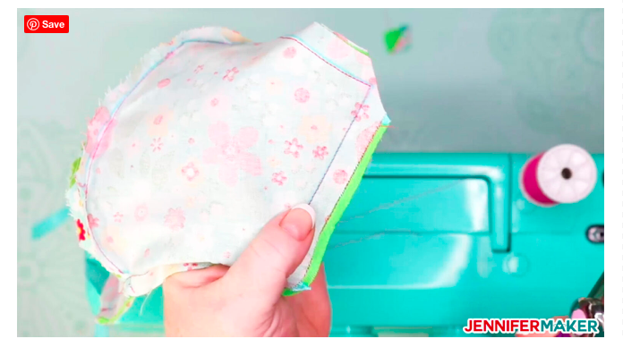

Carefully turn your DIY face mask right side out and poke out each corner.

Tip: Having problems getting the corners straight? Poke them from inside with the end of your scissors.

**Step 8:** Turn in and enclose the side that is not sewn. Topstitch around the mask.

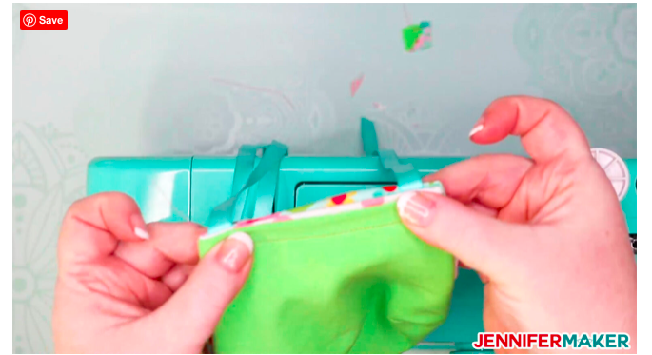

Carefully sew around the side opening, being sure to do a backstitch at the start and end to keep it secure.

**Step 9:** Once it's all sewn up, iron the edges for a nice, crisp appearance and better fit.

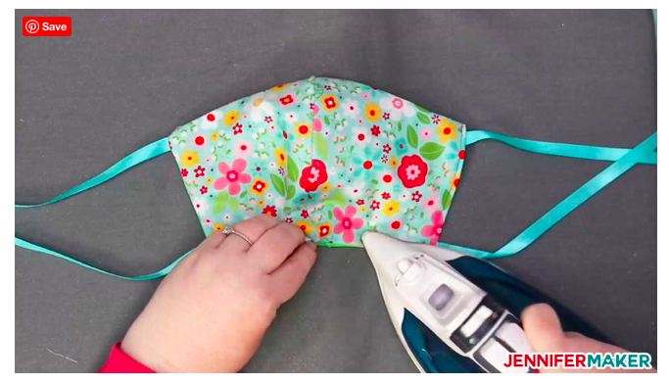

Congratulations! You made a DIY face mask!

Jennifer Maker’s site with the filter: https://jennifermaker.co